Project Short Answer

**Part 1**

1. Experiment a
   1. What percentage of the websites do not respond to pings at all? **22%**
   2. What percentage have at least one failed ping? **33%**
   3. Median RTT CDF Graph

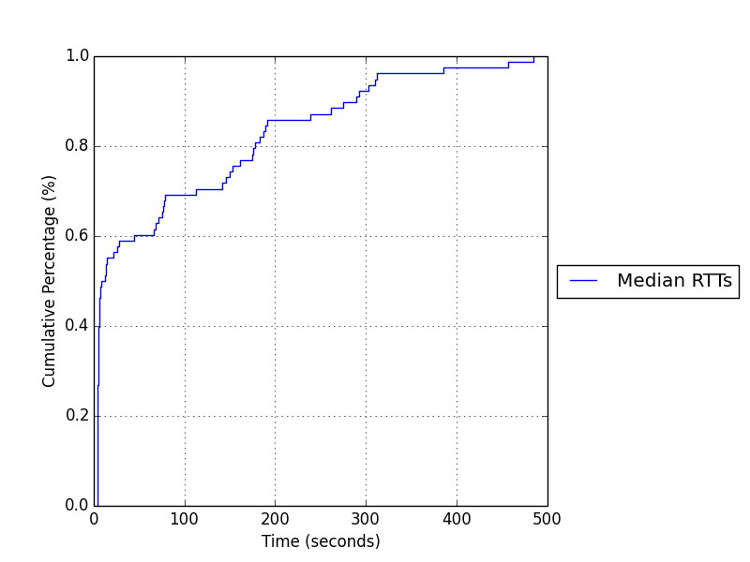

1. Experiment b
   1. Google.com
      1. Median RTT: **4.283ms**
      2. Max RTT: **108.797ms**
      3. Loss Rate: **0.6%**
   2. Taobao.com
      1. Median RTT: **342.404ms**
      2. Max RTT: **597.626ms**
      3. Loss Rate: **69.6%**
   3. Zanvarsity.ac.tz
      1. Median RTT: **327.813ms**
      2. Max RTT: **555.079ms**
      3. Loss Rate: **0.6%**
   4. Todayhumor.co.kr
      1. Median RTT: **80.804ms**
      2. Max RTT: **318.554ms**
      3. Loss Rate: **0.4%**
   5. RTT CDF Graph

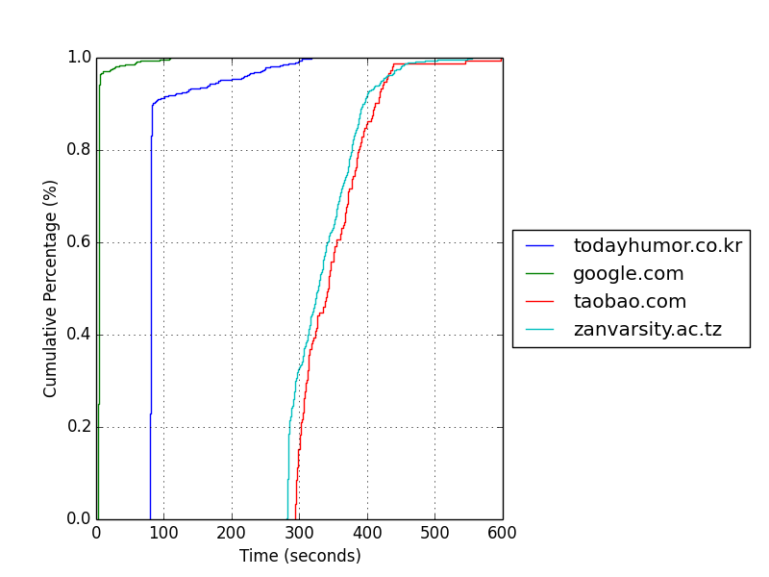

1. Google vs Zanvarsity
   1. Do the calculation
      1. Google speed of light time: **0.378 ms**
      2. Google ping time/speed of light time: **11.331**
      3. Zanvarsity speed of light time: **106.865 ms**
      4. Zanvarsity ping time/speed of light time: **3.068**
   2. There are a couple reasons why the ping time is much slower the speed of light time. First and foremost, the signal travelling through the air, fiber optic cables, and other mediums will never actually travel at the speed of light. In fact, it must be travelling much slower that the speed of light depending on the medium. Second, it is unlikely that the packet takes a straight line path from one end host to another, as we assumed in the speed of light calculation. The routers will be placed at locations designed to optimize coverage and speed of transmission through a network, but the packet will still follow more of a zig-zag path, making the travelled distance much greater. Finally, the time required for processing in the router, such as checking the routing table and determining where to send the packet next, will take time, which is included in the ping time.

**Part 2**

1. Experiment a
   1. Which ASes are Berkeley directly connected to? **AS0, AS25**
   2. Which traceroute traverses the most number of ASes? How about the least number of ASes? **Most: piranha.ro.vutbr.cz, zanvarsity.ac.tz Least: www.w3.berkeley.edu**
   3. Which websites' routes are load-balanced?

**All of them except www.w3.berkeley.edu and piranha.ro.vutbr.cz**

* 1. Are the observed routes stable over multiple runs? For each website, how many unique routes did you observe?

**There are multiple unique roots for all of the websites.**

* 1. Using one sentence, please explain one advantage of having stable routes.

**With stable routes, there is not much of an overhead of calculating new routes unless something in the network changes that would affect the route.**

1. Experiment b
   1. How many hops do you observe in each route when you run traceroute *from* your computer? How many hops do you observe in the reverse direction?

tpr-route-server.saix.net: To: **13** From: **20**

route-server.ip-plus.net: To: **14** From: **10**

route-views.oregon-ix.net: To: **8** From: **7**

route-views.on.bb.telus.com: To: **10** From: **15**

* 1. Are these routes symmetric? How many are symmetric and how many are not?

**1 is symmetric, 3 are not. The routes to and from “**route-views.oregon-ix.net” **are the ones that seem to be almost perfectly symmetric.**

* 1. What might cause asymmetric routes? List one or two reasons.

**An asymmetric route may be caused when packets encounter routers with different routing policies, or with differing information in their routing tables.**

**Part 3**

1. What's the average root TTL in the 5 iterations of the top Alexa websites? Average TLD TTL? Average other name server TTL? Average terminating entry TTL?

**Root: 132343.0, TLD: 172800.0, Other Name: 149095.0, Terminating: 43561.0**

1. Plot a CDF of your 5 iterations from the Alexa top 100 websites using your generate_time_cdfs function (this should have two lines, as described above).

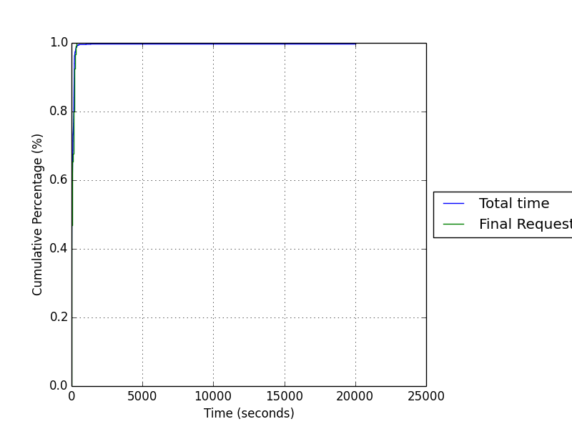

1. Run run_dig twice at least 1 hour apart. How many answers change within the first trial? How many names gave different answers at some point in the two trials (i.e., what values does count_different_dns_responses return?)?

**Changes in 1st trial: 9 Changes in both trials: 32**

1. Run run_dig using the name of a server in a different country. You can find public DNS servers in other countries [here](http://public-dns.info/). Run count_different_dns_responses with your original trace and the one from the new country. What does it return?

**Changes in 1st trial: 9 Changes in both trials: 79**

1. Take a look at a few of the names that returned different answers when you queried a different name server in part d. Use ping to measure the round trip time to the different IP addresses returned. What's the most likely reason that the different DNS server returned a different IP address? Answer in one sentence (you do not need to provide your ping output).

**Either there is a NAT with the destination IP located behind the NAT, or there is load-balancing occurring at the destination IP.**

1. **Query resolution occurs more quickly because we will not have to iteratively record and send back the times to the intermediate servers (root, TLD, other), rather, without the +trace command, the dig command quickly returns the query completion time for the final destination IP.**